**Enhancing the Employee Experience**

**Note-Taking Guide**

***Presented by IMA Leadership Academy***

*Copyright © 2020 IMA® (Institute of Management Accountants). All rights reserved.*

# A picture containing person, holding, person, standing Description automatically generatedTODAY’S AGENDA

1. Introduction
2. The Basics
3. Measuring Employee Experience
4. The Manager’s Role
5. Close

# LEARNING OBJECTIVES

After this session, you’ll be able to:

* Define employee experience and differentiate it from employee engagement.
* Describe the benefits challenges of enhancing the employee experience.
* Identify processes or methods for measuring the employee experience.
* Explain the manager’s responsibilities for developing the employee experience.

# REFLECTION

1. How would you define employee experience?
2. As a manager, what can you do to enhance the employee experience of your team members?

**DEFINITIONS OF EMPLOYEE EXPERIENCE**

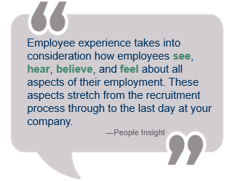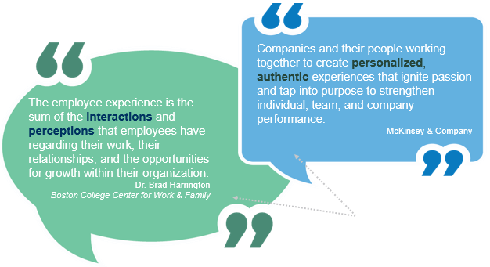

Source: See Bibliography [4,5,7]

**EMPLOYEE ENGAGEMENT**

“Employee engagement is the extent to which employees feel passionate about their jobs, are committed to the organization, and put discretionary effort into their work.”

—“What Is Employee Engagement?” CustomInsight,

**“MY MANAGER”**

**THE ORGANIZATION**

**ENGAGEMENT VS. EXPERIENCE**

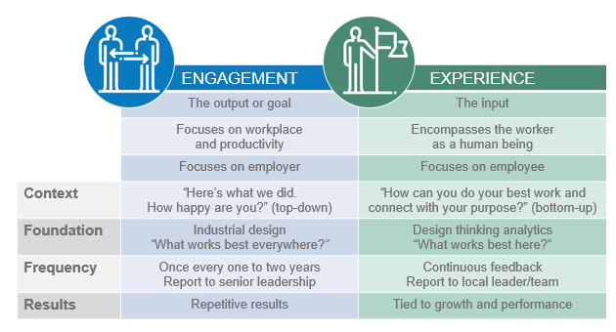

Source: See Bibliography [5,14]

**BENEFITS**

Companies that place an emphasis on employee experience vs. those that don’t:

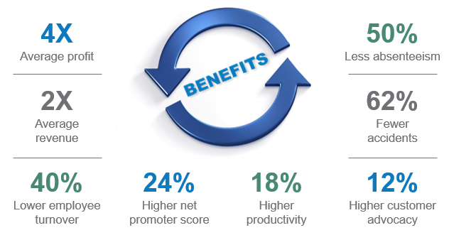

Source: See Bibliography [1,5]

**CHALLENGES**

1. Many companies delegate experience to an annual engagement survey.
2. Most companies haven’t assigned employee experience responsibility to a senior executive or team.
3. It’s often difficult to obtain resources for an integrated set of priorities
4. Companies need to update their tools to get the constant feedback needed for employee experience management.
5. Many companies remain focused on “point-in-time engagement.”

**GALLUP’S SEVEN STAGES OF EMPLOYEE EXPERIENCE**

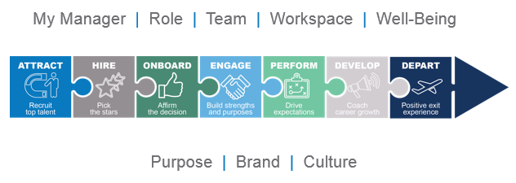

Source: See Bibliography [23]

**DELOITTE’S SIMPLY IRRESISTIBLE ORGANIZATIONTM MODEL**

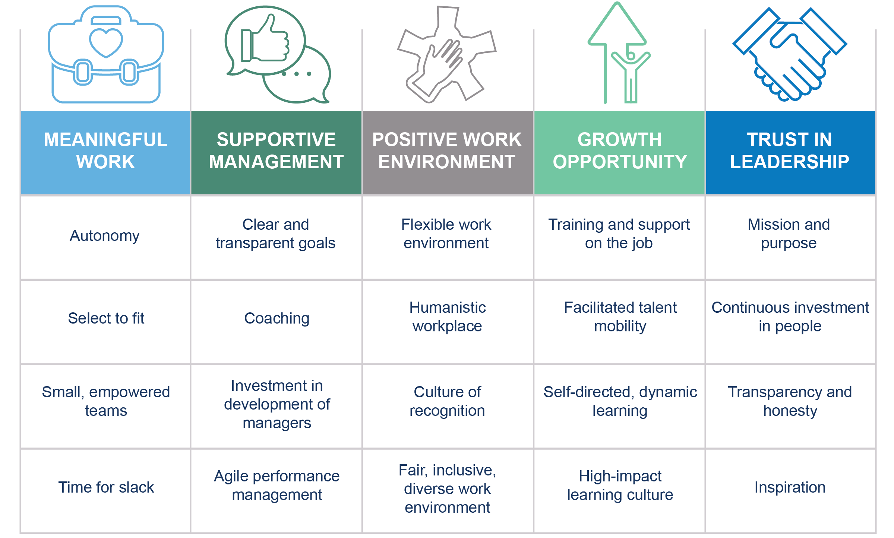

Source: See Bibliography [2]

**METHODS TO COLLECT EXPERIENCE DATA**

1. Surveys
2. Breakathons
3. Face-to-face interviews
4. Focus groups
5. Feedback apps

Source: See Bibliography [14]

**CREATING EFFECTIVE SURVEYS**

1. Ask questions related to observable behavior, not thoughts or motives.
2. Measure only those behaviors that are linked to your organization’s performance.
3. About one-third of questions should lead to a negative response.
4. Avoid questions that require rankings.
5. Make sure that the survey can be completed within 20 minutes.
6. Make sure the interface for the survey is user-friendly

Source: See Bibliography [17]

**ADDITIONAL STRATEGIES TO   
GATHER EXPERIENCE INSIGHTS**

1. Design thinking methodology
2. Value stream mappings
3. Kaizen sessions
4. Online communication tools
5. Customer-feedback tools

Source: See Bibliography [14]

**EXPERIENCE METRICS**

* Engagement
* A person standing posing for the camera

  Description automatically generatedNet promoter score
* Retention of top talent
* Earnings before interest and taxes (EBIT)
* Net profit
* Market share

Source: See Bibliography [14]

**EMPLOYEE EXPERIENCE INDEX**

|  |  |  |  |
| --- | --- | --- | --- |
| **Physical Space**  Max: 26 | **Culture**  Max: 70 | **Technology**  Max: 19.5 | **Overall**  Max: 115.5 |

Source: See Bibliography [21]

**PEARLTM EMPLOYEE EXPERIENCE MODEL**

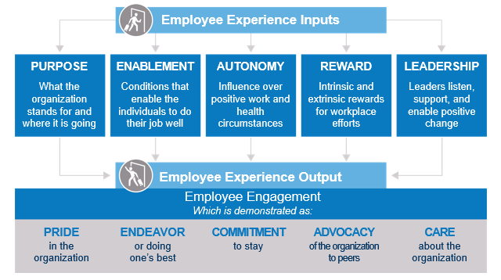

Source: See Bibliography [5]

**BALANCED SCORECARD**

* Used to capture, describe, and translate intangible assets into real value for all of an organization’s stakeholders.
* Allows organizations to implement their differentiating strategies successfully.
* Translates an organization’s strategy into performance objectives, measures, targets, and initiatives in four balanced perspectives: financial, customer, internal process, and employee learning and growth.
* Based on solid strategy and objectives, answers the question, “How will we know if we are successful in achieving this objective?”

Source: See Bibliography [17]

**THE MANAGER’S IMPACT ON   
THE EMPLOYEE EXPERIENCE JOURNEY**

Examples of the manager’s impact on Gallup’s seven stages of the employee journey:

* **Attract:** Millennials say that “quality of manager” is a top factor they consider when looking for a new job.
* **Onboard:** When managers play an active role in onboarding, employees are 2.5 times more likely to strongly agree their onboarding was exceptional.
* **Engage:** Managers account for an astounding 70% of the variance in their team’s engagement.
* **Perform:** Only two in ten employees strongly agree that their performance is managed in a way that motivates them to do outstanding work.
* **Depart:** Fifty-two percent of exiting employees say that their manager could have done something to prevent them from leaving their job. Only 51% of employees who left their job had a conversation about their engagement, development, or future during the three months leading up to their departure.

Source: See Bibliography [23]

# QUESTIONS FOR EACH STAGE OF THE EMPLOYEE JOURNEY

**Attract and Hire**

* Does the candidate feel they have been treated fairly and equally?
* Have their contacts from the organization “lived” the organization’s values?
* Have they had a positive experience of the meeting places, technology, and tools used through the process?

**Onboard**

* Does the employee know how to use the various technologies and tools your company relies on?
* Has your new employee been made to feel like a part of the team?
* Does your employee know where they can get the support and resources they need?
* Does your new hire know what you expect of them?

**Engage and Perform**

* Does the employee feel they are getting enough feedback?
* How often does the employee meet one-on-one with their line manager?
* Does the employee feel supported and encouraged by those around them?
* Does the employee feel they have fair and equal access to development opportunities?

**Depart**

* Does the employee feel valued for the work they have done for your business?
* Does the employee feel that sufficient measures were put in place to ensure they had a good experience at your company?
* Did the employee feel fairly treated throughout their employee journey?

Source: See Bibliography [5]

**UNDERSTANDING EMPLOYEES’ “WHY”**

1. What were the employee’s experiences, and what led them to us?
2. Why did the employee stay with us?
3. What sets our organization apart?
4. Discuss the subject of salary directly and clearly.
5. Why does the employee have the existing position with us?
6. What would tempt the employee to accept another position elsewhere?
7. Discuss what the employee sees as their overall career plan.
8. Discuss the annual performance review process, content, and results.
9. If the employee completed a performance review of peers, direct manager, and senior management, what would it reflect?

Source: See Bibliography [19]

**CONDUCTING STAY INTERVIEWS**

* Are you recognized for your accomplishments?
* Does your immediate manager support you in matching your skills and desires to your career goals?
* Are you challenged in your day-to-day work?
* Is the training you want available to you?
* Has your manager helped you develop a career action plan?
* Does your manager give you regular, candid feedback?
* What are you struggling with all the time?
* What would make your life easier?
* What makes you unique in this organization?
* Tell me about an accomplishment of which you’re particularly proud.
* What are your most important values? Which values are met and not met at work?
* If you had to choose among working with people, data, things, or ideas, which combination would make you the happiest? Why?

Source: See Bibliography [10]

**ENRICHMENT POSSIBILITIES**

* Combine tasks.
* Form teams.
* Put employees in touch with clients.
* Rotate assignments.
* Build in feedback.
* Establish widespread participation.
* Nurture creativity.
* Set goals.

Source: See Bibliography [10]

ACTION PLAN

Answer the following four questions.

|  |  |
| --- | --- |
| How will you and your team benefit from what you learned or were reminded of today? | How will your organization benefit from what you learned or were reminded of today? |
| How might your job change as a result of what you learned or were reminded of today? | What is one action you can take in response to what you learned or were reminded of today? |

# BIBLIOGRAPHY

[1] Chiradeep BasuMallick, “Employee Engagement vs. Employee Experience: Are They Really That Different?” HR Technologist, May 28, 2019, [www.hrtechnologist.com/articles/employee-engagement/employee-engagement-vs-employee-experience-are-they-different/](http://www.hrtechnologist.com/articles/employee-engagement/employee-engagement-vs-employee-experience-are-they-different/).

[2] Josh Bersin, Jason Flynn, and Arthur H. Mazor, “The employee experience: Culture, engagement, and beyond,” Deloitte Insights,February 28, 2017, [www2.deloitte.com/us/en/insights/focus/human-capital-trends/2017/improving-the-employee-experience-culture-engagement.html](https://www2.deloitte.com/us/en/insights/focus/human-capital-trends/2017/improving-the-employee-experience-culture-engagement.html).

[3] “Building a High-Development Culture Through Your Employee Engagement Strategy,” Gallup, February 21, 2019, [www.gallup.com/workplace/285800/development-culture-engagement-paper-2019.aspx](http://www.gallup.com/workplace/285800/development-culture-engagement-paper-2019.aspx).

[4] Naina Dhingra, Jonathan Emmett, and Mahin Samadani, “Employee experience: essential to compete,” McKinsey & Company, March 12, 2018, [www.mckinsey.com/business-functions/organization/our-insights/the-organization-blog/employee-experience-essential-to-compete](https://www.mckinsey.com/business-functions/organization/our-insights/the-organization-blog/employee-experience-essential-to-compete).

[5] “Employee Experience vs Employee Engagement: What’s the Difference?” People Insight,February 24, 2020, [peopleinsight.co.uk/employee-experience-vs-engagement/](https://peopleinsight.co.uk/employee-experience-vs-engagement/).

[6] Shane Green, *Culture Hacker,* John Wiley & Sons, Inc., Hoboken, N.J., April 2017.

[7] Brad Harrington, “Maximizing the Employee Experience: How Changing Workforce Dynamics are Impacting Today’s Workplace,” Boston College Center for Work & Family White Paper, [www.bc.edu/content/dam/files/centers/cwf/research/publications/researchreports/Maximizing%20the%20Employee%20Experience%20White%20Paper.pdf](http://www.bc.edu/content/dam/files/centers/cwf/research/publications/researchreports/Maximizing%20the%20Employee%20Experience%20White%20Paper.pdf).

[8] Douglas W. Hubbard, *How to Measure Anything: Finding the Value of Intangibles in Business,* 3rd edition, John Wiley & Sons, Inc., Hoboken, N.J., February 2014.

[9] Urmila Itam and Nitu Ghosh, “Employee Experience Management: A New Paradigm Shift in HR Thinking,” *International Journal of Human Capital and Information Technology Professionals*, April-June 2020.

[10] Beverly Kaye and Sharon Jordan-Evans, *Love 'Em or Lose 'Em: Getting Good People to Stay*, 3rd edition, Berrett-Koehler Publishers, San Francisco, Calif., 2005.

[11] Sandeep Kular, Mark Gatenby, Chris Rees, Emma Soane, and Katie Truss, “Employee Engagement: A Literature Review,” working paper, Kingston University, October 2008, [eprints.kingston.ac.uk/id/eprint/4192/1/19wempen.pdf](https://eprints.kingston.ac.uk/id/eprint/4192/1/19wempen.pdf).

[12] Jacob Morgan, “What Is Employee Experience?” *Forbes*, April 22, 2016, [www.forbes.com/sites/jacobmorgan/2016/04/22/what-is-employee-experience/#294cd0fe7386](http://www.forbes.com/sites/jacobmorgan/2016/04/22/what-is-employee-experience/#294cd0fe7386).

[13] Jacob Morgan and Marshall Goldsmith, *Employee Experience Advantage,* John Wiley & Sons, Inc., Hoboken, N.J., March 2017.

[14] Elliott Nelson and Hannah Olvera Doman, “Employee Experience: How to Build an EX-Centric Organization,” KennedyFitch, [www.kennedyfitch.com/KFwebsite-new/wp-content/uploads/Employee-Experience-How-to-Build-an-EX-Centric-Organization.pdf](http://www.kennedyfitch.com/KFwebsite-new/wp-content/uploads/Employee-Experience-How-to-Build-an-EX-Centric-Organization.pdf).

[15] Elliott Nelson and Maria Neicu, “Employee Experience 2020: Global Report & Case Studies,” EX Leaders Network, 2019, [www.exleadersnetwork.com/wp-content/uploads/2019/12/EX-2020-Report-by-EX-Leaders-Network.pdf](http://www.exleadersnetwork.com/wp-content/uploads/2019/12/EX-2020-Report-by-EX-Leaders-Network.pdf).

[16] Paul R. Niven, *Balanced Scorecard Evolution: A Dynamic Approach to Strategy Execution,* John Wiley & Sons, Inc., Hoboken, N.J., August 2014.

[17] Paul R. Niven, *Balanced Scorecard Step-by-Step: Maximizing Performance and Maintaining Results*, 2nd edition, John Wiley & Sons, Inc., Hoboken, N.J., 2006.

[18] Anubhav Pandey and Sakshi Gupta, “Defining Employee Experience as an Antecedent Indicator for Employee Productivity,” *International Journal of Research in Engineering, Science and Management*, May 2020, [www.ijresm.com/Vol.3_2020/Vol3_Iss5_May20/IJRESM_V3_I5_20.pdf](http://www.ijresm.com/Vol.3_2020/Vol3_Iss5_May20/IJRESM_V3_I5_20.pdf).

[19] Mike Phillips, “What’s Your Why?” *Strategic Finance*, August 1, 2017, [sfmagazine.com/post-entry/august-2017-whats-your-why/](https://sfmagazine.com/post-entry/august-2017-whats-your-why/).

[20] Lavinia Rasca, “Employee Experience—An Answer to the Deficit of Talents, in the Fourth Industrial Revolution,” *Quality—Access to Success*, October 2018.

[21] “The Employee Experience Index,” The Future Organization—Jacob Morgan, [thefutureorganization.com/employee-experience-index/](https://thefutureorganization.com/employee-experience-index/).

[22] Rebecca Vineyard, “What Is Employee Experience vs Employee Engagement?” Lattice, October 13, 2019, [lattice.com/library/what-is-employee-experience-vs-employee-engagement](https://lattice.com/library/what-is-employee-experience-vs-employee-engagement).

[23] Ben Wigert and Ellyn Maese, “How Your Manager Experience Shapes Your Employee Experience,” Gallup, July 9, 2019, [www.gallup.com/workplace/259469/manager-experience-shapes-employee-experience.aspx](https://www.gallup.com/workplace/259469/manager-experience-shapes-employee-experience.aspx).

**ACKNOWLEDGMENTS**



Presentation produced by: Ignite It Group (www.igniteitgroup.com)

**CONTACT US**

For more information about this or other programs, please contact IMA.

www.imanet.org

10 Paragon Drive, Suite 1, Montvale, New Jersey 07645-1760

US (800) 638-4427 or International +1 (201) 573-9000

*Copyright © 2020 IMA® (Institute of Management Accountants). All rights reserved.*