**Financial Leadership**

**Note-Taking Guide**

***Presented by IMA Leadership Academy***

# TODAY’S AGENDA

1. Overview
2. What is Financial Leadership?
3. Financial Leadership Knowledge, Skills, and Abilities (KSAs)
4. Strategies for Becoming a Financial Leader
5. Close

# LEARNING OBJECTIVES

After this session, you will be able to:

* Recognize the importance of financial leadership in the current and future marketplace.
* Describe the knowledge, skills, and abilities (KSAs) associated with financial leadership.
* Detail the steps management accountants should take to grow as financial leaders and valued business partners.
* Examine real-world scenarios and applications of successful financial leadership.

# REFLECTION

What does financial leadership look like for you?

What qualities are important to good financial leadership?

**MANAGEMENT ACCOUNTING’S CHANGING ROLE**

|  |  |
| --- | --- |
| Traditionally: | Now expanding to include: |
| * Processing transactions * Accounting for wealth | * All of the above * Decision support * Creating wealth * Influence as a business partner |

Source: See Bibliography [23]

# AN EXAMPLE OF FINANCIAL LEADERSHIP

A financial analyst at a software company noticed that one of the segments had not hit its sales plan for the month, so he dug into the data more deeply and identified specific customers who had not renewed their software licenses. He had a conference with the sales team and gave them the list of customers and soon discovered that many of the lapsing customers had simply not been contacted about their expiring licenses. These customers were revenue opportunities that had been overlooked. He put together a list of all of the customers that had lapsed and worked with his sales partners to ensure all of the customers were contacted to determine their status. He held weekly follow-up calls with the salespeople to check on progress and reported the progress to the sales management team. As a result, the segment was able to capture $10 million in incremental revenue and met its revenue goal for the quarter.

How is this financial analyst demonstrating financial leadership?

**DRIVERS OF CHANGE**

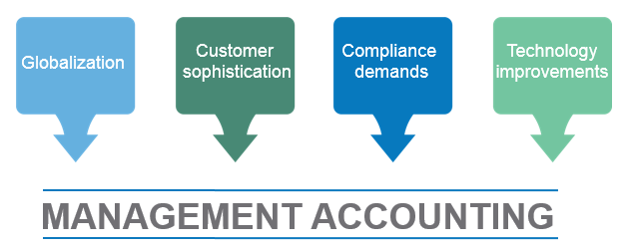

**AN EVOLVING INDUSTRY**

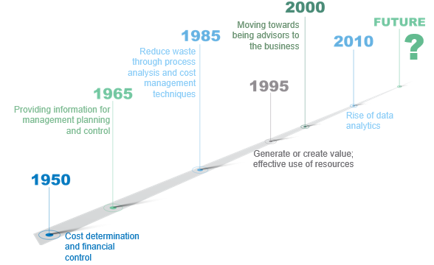

# ANOTHER EXAMPLE OF FINANCIAL LEADERSHIP

…in 1990, Caterpillar reorganized itself into profit centers. Before the reorganization, we were an extremely centralized, bureaucratic company, with decisions being made at the top. Then we changed from a functional organization to one that was organized on a profit-center basis with about 26 profit centers or business units. The person in charge of running a business unit was evaluated on return on investment and the unit’s profitability. Each vice president had to run his business with a P&L. Each unit had a business manager reporting to the profit center in that organization. These business managers were accountants. With the creation of business units, obviously, you become a business manager rather than an accountant. As a business manager, you get involved in all aspects of the business, in finding ways and solutions to help the business achieve strategic objectives.

…after the reorganization we had an entrepreneurial relationship within that plant. Caterpillar created, for the first time, high-level managers at the plant level who had total responsibility for the product, for the design, manufacturing, pricing, and all those functions that used to be in a central location in the functional organization. Then the business manager was created at the business-unit level who was at as high a level as the product managers who ran the company.

What helped make the accountants partners and a big part of the management community is that each vice president relied on us to help run his business. We analyzed the results, answered questions about why things were better, and, maybe even more important, why things were worse. This is critical.

To get people to really understand what we were doing, we spent a large amount of time training this new organization that we split into business units. The accountants took on the burden of educating the various divisions about what the numbers meant and how they could impact them… Everybody was interested because they knew it was going to impact their incentive plan. We taught them what financial results are, how we get the information, and how we measure it. We showed them how a welder impacts our business, how a purchasing person impacts our business. This put us in something like a counseling position because we were the teachers. One of the great things that the reorganization did in unbundling the corporation and developing 26 different business units was to create 1,000 businesspeople….

We accountants took the leadership role, became counselors, and helped cultivate a real business sense within Caterpillar. We would have floundered had we not done that. These businesspeople we created came back to us and involved us in running their business, which was a major transformation for the company.

Source: See Bibliography [22]

What qualities of a financial leader are revealed in this story?

**BEING A BUSINESS PARTNER**

* Holds fiduciary responsibility
* Carries out traditional accounting functions
* Has an overview of the organization as a whole
* Provides an understanding of the financial implications of actions
* Focuses on running the business
* Accounting is a vehicle to improve performance and decision making
* More emphasis on sharing and using information
* Participates in creating strategy as well as carrying out strategy

Source: See Bibliography [21]

**BEING A TRUSTED FINANCIAL LEADER**

* Is reliable
* Is technically competent
* Provides business insight
* Can influence outcomes
* Communicates why something happened and what will likely happen
* Decides whether or not to take action
* Has an entrepreneurial spirit with a bias toward action to seize opportunities
* Focuses on what could happen
* Leverages their view of the big picture of the company to drive decisions

Source: See Bibliography [9]

# A THIRD EXAMPLE OF FINANCIAL LEADERSHIP

New technologies regularly emerge, and in some cases, their business use may not be immediately clear. Historically, management accountants haven’t concerned themselves with emerging technologies, but financial leaders routinely look on the horizon for opportunities that improve results. Blockchain is one example. Blockchain is a growing list of records, called blocks that are linked using cryptography. Blockchain establishes a trusted environment for all transactions, which is ideal for situations that require a reliable audit trail across multiple vendors, partners, and organizations that may not use similar financial and operating systems. Blockchain makes transactions more secure and traceable.

The finance team at a software company recently adopted blockchain technology to improve the reporting of royalties to third parties, which reduced the costs related to auditing and tracing transactions to identify errors. The business needed a solution to make the process easier and less costly, and the finance team was familiar with the advantages of using blockchain, which allowed it to step in and lead the way to a more effective and efficient solution.

Financial leaders keep an eye on emerging trends and technologies to determine if opportunities exist to solve existing problems and help the business succeed. Financial leaders are more than just accountants or advisors, they are leaders who solve tough problems using their broad understanding of entire business landscape.

**BECOMING A FINANCIAL LEADER**

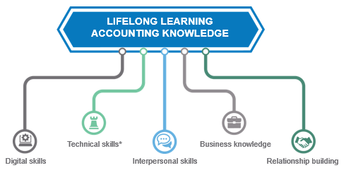

*Technical skills: risk management, forecasting, budgeting, data analytics, etc.

**FOUR “LINES OF SIGHT” FOR FINANCIAL LEADERS**

* Oversight
* Hindsight
* Insight
* Foresight

**DIGITAL COMPETENCIES NEEDED**

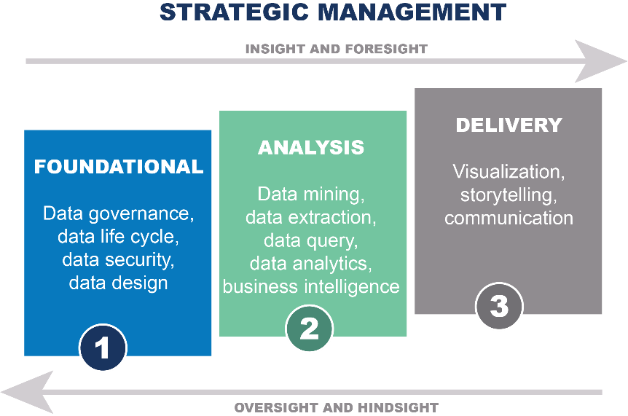

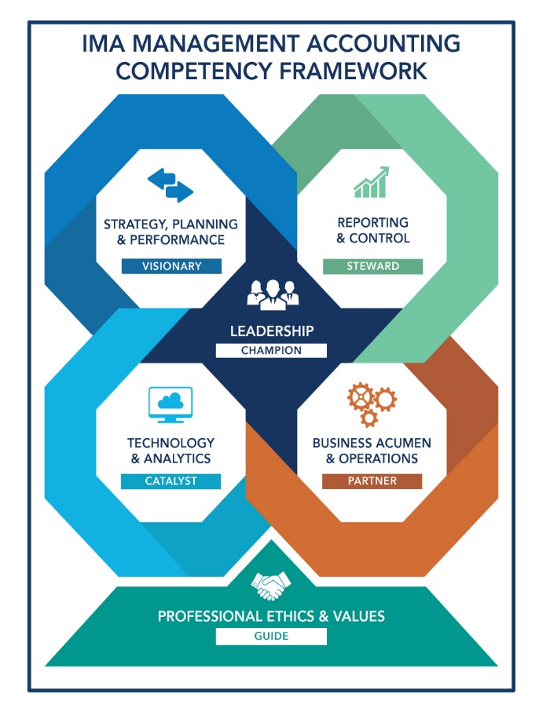

|  |  |  |
| --- | --- | --- |
| **STRATEGY, PLANNING & PERFORMANCE** | The competencies required to envision the future, lead the strategic planning process, guide decisions, manage risk, and monitor performance. | * Strategic and tactical planning * Decision analysis * Strategic cost management * Capital investment decisions * Enterprise risk management * Budgeting and forecasting * Corporate finance * Performance management |
| **REPORTING & CONTROL** | The competencies required to measure and report an organization’s performance in compliance with relevant standards and regulations. | * Internal control * Financial recordkeeping * Cost accounting * Financial statement preparation * Financial statement analysis * Tax compliance and planning * Integrated reported |
| **TECHNOLOGY & ANALYTICS** | The competencies required to manage technology and analyze data to enhance organizational success. | * Information systems * Data governance * Data analytics * Data visualization |
| **BUSINESS ACUMENT & OPERATIONS** | The competencies required to contribute as a cross-functional business partner to transform company-wide operations. | * Industry-specific knowledge * Operational knowledge * Quality management and continuous improvement * Project management |
| **LEADERSHIP** | The competencies required to collaborate with others and inspire teams to achieve organizational goals. | * Communication skills * Motivating and inspiring others * Collaboration, teamwork, and relationship management * Change management * Conflict management * Negotiation * Talent management |
| **PROFESSIONAL ETHICS & VALUES** | The competencies required to demonstrate the professional values, ethical behavior, and legal compliance essential to a sustainable business model. | * Professional ethical behavior * Recognizing and resolving unethical behavior * Legal and regulatory requirements |

**CAREERDRIVER**

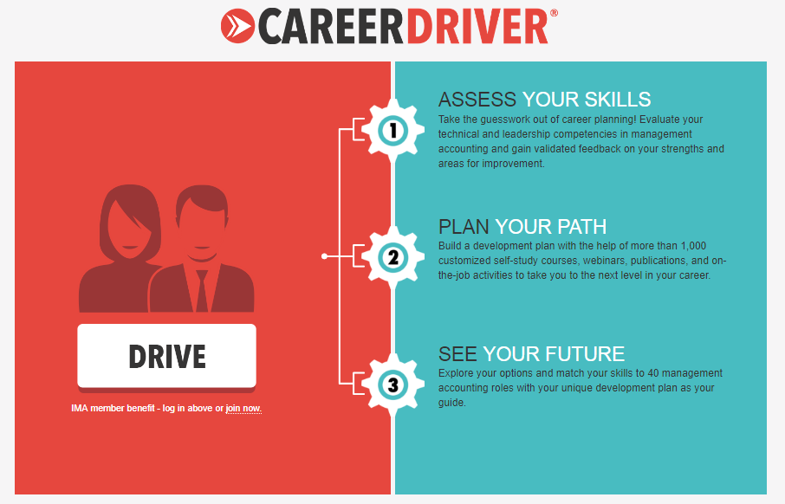

**QUALITIES OF A FINANCIAL LEADER**

|  |  |
| --- | --- |
| * Increased emphasis on foresight and insight, to complement hindsight and oversight * Catalyst and strategist * High ethical standards * Strong business acumen and core business skills * Commercially aware * Confident decision maker * Relationship builder | * Honesty and integrity * Ability to interpret data * Well-developed ideas and opinions * Comfortable with risk * Future-oriented * Excellent communication and interpersonal skills * Financial judgment and decision making |

**FOOD FOR THOUGHT**

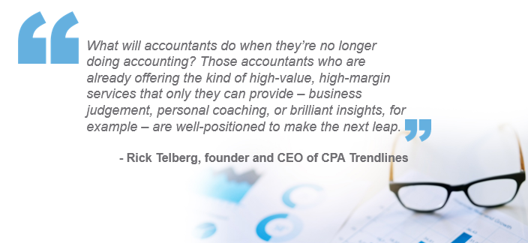

Source: See Bibliography [10]

**PREPARING FOR THE CHANGE**

* Build the foundation
* Develop your interpersonal skills
* Develop informal relationships across the organization
* Understand the business
* Educate the organization

**TRANSITIONING STRATEGIES**

* Show value-added analysis
* Gain trust
* Balance financial, strategic, and operational perspectives
* Give high-quality advice
* Help users of financial information find solutions
* Help the “financially challenged” understand the information
* Understand the needs of decision makers
* Promote the value of financial advice
* Be involved in all stages of decision making
* Be persistent

Source: See Bibliography [22]

**WHAT TO DO TO BE A FINANCIAL LEADER**

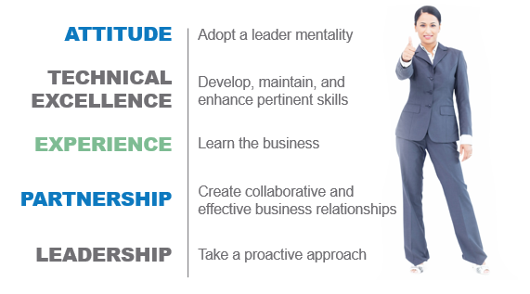

Source: See Bibliography [9]

**DISCIPLINES OF A FINANCIAL LEADER**

* Be trustworthy
* Be credible
* Think strategically
* Leverage technology or technical advances
* Develop a management perspective
* Advise constructively
* Anticipate
* Be courageous
* Communicate effectively

**PROFESSIONAL DEVELOPMENT CONTINUUM**

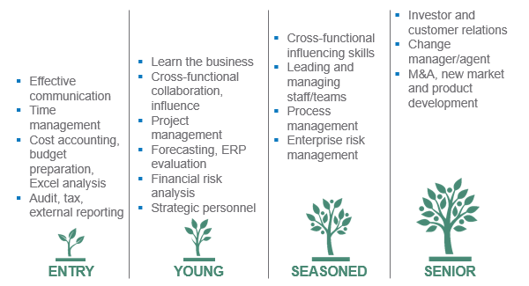

Where are you on this continuum?

Is there anything you should be doing differently to develop your KSAs at this point?



**COMMON OBSTACLES**

|  |  |
| --- | --- |
| Lack of   * Time * Expertise * Top-management support * Operational support | Difficulties with   * Culture * Trust * Attitudes * Gaining access to information |

**TOP SKILLS AND QUALITIES TO DEVELOP**

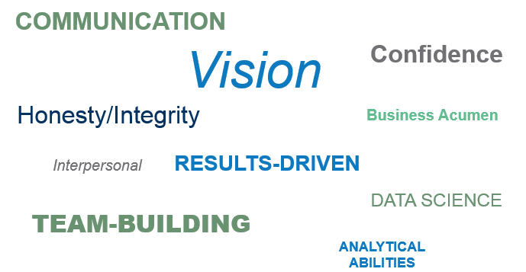

Source: See Bibliography [18,21]

**IT’S ABOUT YOU**

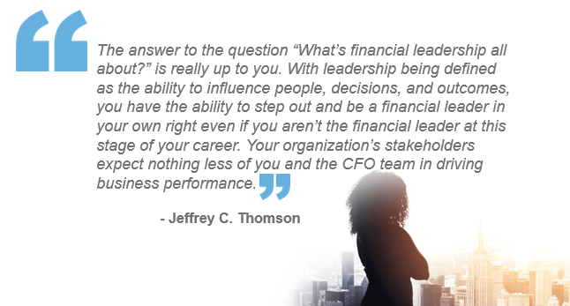

Source: See Bibliography [23]

ACTION PLAN

My goal in relation to financial leadership is _____________________________________________

________________________________________________________________________________

________________________________________________________________________________

|  |  |
| --- | --- |
| **The *Barriers* to my goal are…** | **The *Enablers* to my goal are…** |
|  |  |
|  |  |
|  |  |
|  |  |
|  |  |
|  |  |
|  |  |

***ACTIONS:***To deal with these barriers or secure/nurture the enablers, I will…

**BIBLIOGRAPHY**

[1] “Beyond the Numbers: Financial Executives’ Roles Continue to Expand,” Robert Half Management Resources*,* August 2, 2018, http://rh-us.mediaroom.com/2018-08-02-Beyond-The-Numbers-Financial-Executives-Roles-Continue-To-Expand.

[2] “Finance process transformation enables greater controllership, 15% productivity gain, and global standardization for a major pharmaceutical company,” Genpact Case Study, 2014, www.genpact.com/docs/resource-/finance-process-transformation-enables-greater-controllership-15-productivity-gain-and-global-standardization-for-a-major-pharmaceutical-company.

[3] “IBM Announces Major Blockchain Collaboration with Dole, Driscoll’s, Golden State Foods, Kroger, McCormick and Company, McLane Company, Nestlé, Tyson Foods, Unilever and Walmart to Address Food Safety Worldwide,” IBM Press Release, August 22, 2017, www-03.ibm.com/press/us/en/pressrelease/53013.wss.

[4] IMA, “IMA Management Accounting Competency Framework,” 2018, www.imanet.org/career-resources/management-accounting-competencies.

[5] Association of Chartered Certified Accountants and IMA, “The Data Revolution,” November 2016, www.imanet.org/-/media/3cc5e7215529457a8dc3816c81452d95.ashx.

[6] IMA, “The Future of the Accountant in Business: Thriving in the Digital Age,” 2018.

[7] “What is a Finance Business Partner?” Chartered Accountants Ireland, www.charteredaccountants.ie/professional-development/specialist-qualifications/Diploma-in-Strategic-Finance--Analytics/What-is-a-finance-business-partner.

[8] Peter C. Brewer, “Redefining Management Accounting: Promoting the Four Pillars of Our Profession,” *Strategic Finance*, March 2008, pp. 27-34, http://sfmagazine.com/wp-content/uploads/sfarchive/2008/03/Redefining-Management-Accounting.pdf.

[9] David J. Elrod, “Becoming a Trusted Leader,” *Strategic Finance*, April 2012, pp. 25-27, http://sfmagazine.com/wp-content/uploads/sfarchive/2012/04/LEADERSHIP-Becoming-a-Trusted-Leader.pdf.

[10] Daniel Hood, “Accounting leaders tap technology as top concern,” *Accounting Today*, September 25, 2017, www.accountingtoday.com/news/accounting-leaders-tap-technology-as-top-concern.

[11] Raef Lawson, “Management Accounting Education: New Imperatives,” *Strategic Finance*, August 2018, pp. 40-45, http://sfmagazine.com/post-entry/august-2018-management-accounting-education-new-imperatives/.

[12] Raef Lawson, “Management Accounting Competencies: Fit for Purpose in a Digital Age?” IMA, April 2018, https://www.imanet.org/insights-and-trends/the-future-of-management-accounting/management-accounting-competencies---fit-for-purpose-in-a-digital-age?ssopc=1.

[13] Anders Liu-Lindberg, “How Finance Can Become an Analytics Powerhouse,” LinkedIn Pulse, June 23, 2015, www.linkedin.com/pulse/how-finance-can-become-analytics-powerhouse-anders-liu-lindberg.

[14] Anders Liu-Lindberg, “What Finance Business Partnering Really Is About,” LinkedIn Pulse, June 29, 2015, www.linkedin.com/pulse/what-finance-business-partnering-really-anders-liu-lindberg/.

[15] Anders Liu-Lindberg, “Why Accountants Are an Endangered Species,” LinkedIn Pulse, June 16, 2015, www.linkedin.com/pulse/why-accountants-endangered-species-anders-liu-lindberg/.

[16] Anders Liu-Lindberg, “Why We Need Business Partnering Transformation,” LinkedIn Pulse, June 23, 2014, www.linkedin.com/pulse/20140623075448-3379004-why-we-need-business-partnering-transformation/.

[17] Broderick Martinez, “The Rapidly Evolving World of Management Accounting,” Purdue University Global, June 2014, www.purdueglobal.edu/news-resources/management-accounting/.

[18] Daniel Miller, “The 7 Characteristics of a Great Financial Leader,” Innovation Enterprise Channels*,* September 29, 2014, https://channels.theinnovationenterprise.com/articles/151-the-7-characteristics-of-a-great-financial-leader.

[19] Ken Murphy, “Reconciliation Prognosis: Healthy,” *insiderPROFILES,* http://go.trintech.com/rs/187-JVG-370/images/AstraZeneca-CS.pdf.

[20] William G. Shenkir and Paul L. Walker, “Enterprise Risk Management: Frameworks, Elements, and Integration,” IMA, 2014, www.imanet.org/insights-and-trends/risk--management/enterprise-risk-management.

[21] Gary Siegel, James E. Sorensen, and Sandra B. Richtermeyer, “Are You a Business Partner?” *Strategic Finance*, September 2003, pp. 1-5, http://sfmagazine.com/wp-content/uploads/sfarchive/2003/09/Are-You-a-Business-Partner.pdf.

[22] Gary Siegel, James E. Sorensen, and Sandra B. Richtermeyer, “Becoming a Business Partner: Some Advice on Making the Transition,” *Strategic Finance*, October 2003, pp. 1-5, http://sfmagazine.com/wp-content/uploads/sfarchive/2003/10/Becoming-a-Business-Partner.pdf.

[23] Jeffrey C. Thomson, “Financial Leadership: What’s It All About?” *Strategic Finance*, April 2008, pp. 35-41, http://sfmagazine.com/wp-content/uploads/sfarchive/2008/04/Financial-Leadership-Whats-It-All-About.pdf.

[24] Anthony Waelter, Beth Kaplan, and Ashley B. Gibson, “Stepping Outside the Box: Elevating the Role of the Controller,” IMA and Deloitte, 2018, www.imanet.org/insights-and-trends/business-leadership-and-ethics/stepping-outside-the-box-elevating-the-role-of-the-controller.

**ACKNOWLEDGMENTS**



Presentation produced by: Ignite It Group (www.igniteitgroup.com)

**CONTACT US**

For more information about this or other programs, please contact IMA.

www.imanet.org

10 Paragon Drive, Suite 1, Montvale, New Jersey 07645-1760

US (800) 638-4427 or International +1 (201) 573-9000